Babatye Mobile App for Barcode Reader

3 AUGUST 2020

LEADER: ROSHAN DHITAL (30361962)

PRODUCT OWNER: Kamal Pun (30371365)

SCRUM MASTER: Riaz Qadir (30364968) DEVELOPER: Haque Mohammad (30379834) SYSTEM ANALYST: JashandeepSingh(30362218)

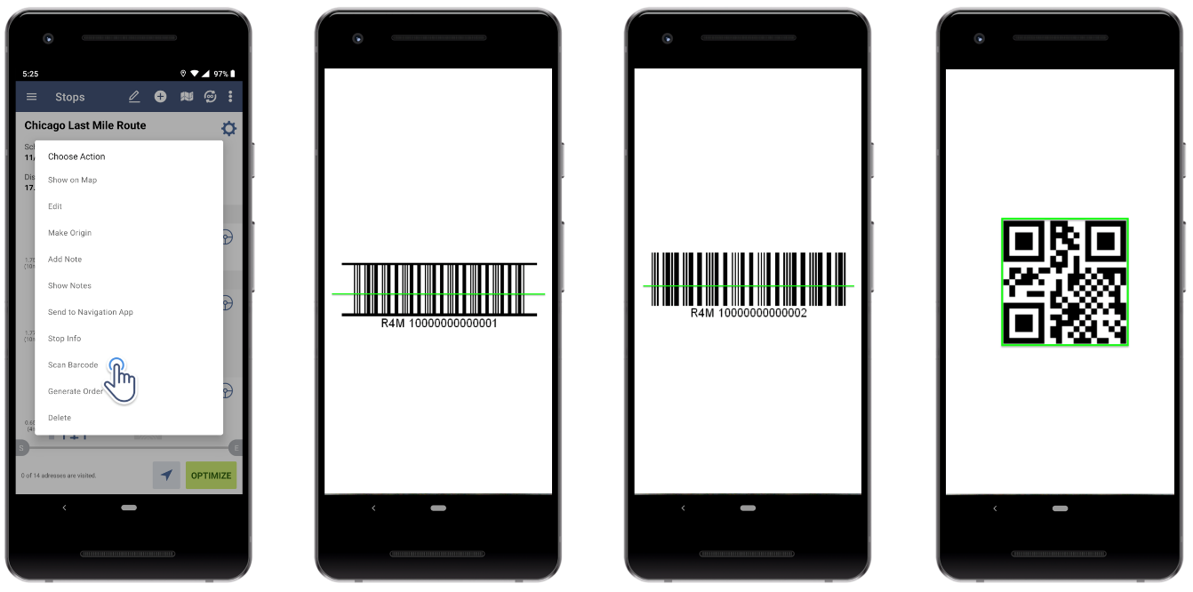

SPRINT 1 DOCUMENTATION AND EVIDENCE

Contents

**Iteration/Sprint Documentation** 2

**Theme & Wishlist** 2

**Our Target:** 2

**Theme:** 3

**Wishlist:** 3

**Incoming Product Backlog** 4

**Sprint Backlog** 5

**Review Meeting** 6

**Retrospective meeting** 9

**Backlog grooming meeting** 12

**Statement of contribution** 13

**Project Vision:** 13

**Product Backlog:** 13

**Project Plan:** 13

**Sprint 1:** 13

**Progress** 14

**Evidence of Progress in Sprint Backlog Tasks** 14

# **Iteration/Sprint Documentation**

# **Theme & Wishlist**

*The target of our project backlog is to make sure developer team work on the right track and are intended to work as the sprint goal with the importance of teamwork. As describe in the scrum guide is the arrangement for the project backlog and it refer to the understanding of the sprint goal which we are currently working on.*

*Improving the backlog time to time will help us to get the accurate point about the client output what they are looking for. It incorporates somewhere around one high need process improvement distinguished in the past Retroactive gathering. This sprint is not just limited on this, but it can also help to understand the progress in time. Project backlog mainly can be change by the developer team only they can change it time to time and submit to the respective one for further instruction.*

## **Our Target:**

1. **EXCITING SCOPE OF WORK**

Everyone love it when it has projects that are exciting and interesting. Those types of projects motivate people to come to work each day and immerse in the work. For our project thankfully we have the scope and opportunity to work like that.

1. **EXCELLENT TEAMWORK**

Teamwork is the engine that makes a project run smoothly. We wish that each of us in this project had a great team contribution that lead us work together effectively and efficiently. It is important that the team works together to resolve issues and supports, leverages, and compliments each other’s strengths. It is also great if we get along well with each other and enjoy each other’s company it can be virtually as well.

1. **EFFICIENT PROJECT PROCESSES**

Smart people hate to waste time (unless of course it is kicking back and watching a good sporting event) and we as a team especially hate wasting time on stupid and inefficient processes. we wish that each process that is defined on the project and most likely by the guidelines we got is efficient and necessary for the effective execution of our project.

1. **PROJECT TOOLS THAT WORK AND ENHANCE THE PROJECT**

Often in the past people have had to use project tools that were clunky and were just a pain to work with. we wish that this time we had in our project tool arsenal the most effective tools that worked efficiently and made our life easier as a participant in the project, not harder.

1. **SUFFICIENT PROJECT RESOURCES**

we think every project managers wish was that they would always have the right amount of resources for their project and that these resources were available when they were needed to perform the work at hand. And we will make sure to work like that.

1. **SATISFIED CLIENT**

The ultimate wish for this project is to be able to provide great value to our client. we wish that each project part work on in the future will deliver everything our client wants and that they are completely satisfied with each deliverable that the team produces.

**Theme:** *“Create registered user who are able to login and start using the app.”*

**Wishlist:** *To create prototype user interface for login and account creation. To build sample database and activity diagram of the account creation process.*

# **Incoming Product Backlog**

|  |  |  |
| --- | --- | --- |
| **Requirement** | **Condition of satisfaction** | **Priority** |
| US1 As a user, I want to create an account so that I can start using scanner app. | Login credentials crated. | Medium |
| US2 As a user, I want to login so that I can start using app to scan barcode of cloths to save time. | Successful login and user can use the app to scan barcodes straightway. | High |
| US3 As a user, I want the app to show user details so that I can review time and details of employee scanning the cloths. | Interface showing details of employee scanning items with time. | Low |
| US4 As a user, I want scanned barcode data to be stores directly into data repository so that I can organise all information. | Scanned data from barcode is stored into data repository. | Critical |
| US5 As a user, I want to store each data in barcode in individual columns into the database so that I can retrieve information individually. | Database has individual columns for different data included in barcode. | Critical |
| US6 As a user, I want to retrieve information according to category, type, weight, size, and colour of the product so that I can track and manage stock in inventory. | Database shows product accordingly and items left in stock. | High |
| US7 As a user, I want to retrieve details of employees and suppliers so that I can process returns and correct missed supplies. | Database shows employees and supplier details. | Medium |
| US8 As a user, I want the system to be flexible so that any additional data included in the barcode may be retrieved. | Database should include new information included in barcode such as material. | High |
| US9 As a user, I want each item to have unique identifier (UID) in database so that it can be searched easily and quickly with that identifier. | All information stored in database have unique identifier and can be searched. | Low |
| US10 As a user, I want the app to be universal so that it can work on any normal mobile irrespective of OS. | App works on any normal mobile. | Critical |
| US11 As a user, I want to manually update information in case app is unable to scan barcode or there is no barcode attached so that | User can update information manually. | Medium |
| US12 As a user, I want to scan all types of barcodes so that any items from different suppliers using different barcodes can be scanned. | App can scan all types of barcodes like Universal barcodes, QR codes and so on. | Critical |

# **Sprint Backlog**

|  |  |  |
| --- | --- | --- |
| **Requirement** | **Condition of Satisfaction** | **Tasks & Estimates** |
| US1 As a user, I want to create an account so that I can start using scanner app. | Account creation page on login page.  Clicking that link user should be directed to registration form.  After putting credentials, the form should send an email to the respective user’s email for verification purpose.  After verification, the user should be able to login with those credentials. | T1 The login page of the app should let the user to enter their credentials like name and email – ½ day (Riaz)  T2 User should be notified if the credentials are incorrect – ½ day (Riaz)  T3 The registration form should let user to submit it through mobile app and send verification email – ½ day (Riaz)  T4 Create page to show successful creation of user login – ½ day Mohammad  T5 User information is stored in data repository – 1 day (Kamal & Jashandeep) |
| US2 As a user, I want to login so that I can start using app to scan barcode of cloths to save time. | The user should be able to login successfully.  The user should be able see mobile app interface.  The app should scan barcode of cloths. | T6 The interface of mobile app should be shown after successful login – 1 day (Roshan)  T7 The app should be able to scan barcodes – 1 day (Roshan & Mohammad)  T8 Information retrieved from barcode is shown in interface – 1 day (Jashandeep)  T9 Design activity diagram of the account creation process – 1 day (Kamal) |

# **Review Meeting**

*The meetings we have been having with our client and supervisor are going well till date and we have been getting positive feedbacks regarding to our work. They tell us about the things that needs to be improved and discuss about the upcoming challenges. To respect everyone’s schedule, we all have agreed on a specific time for the meetings to be held every week. With the client we have meetings every Monday at 11:00 am and with our supervisor we have the meetings at on Tuesday every week at 12:00 pm. Recently our client suggested to have a bit of change in meetings time and everyone agreed on it. Whatever things discussed in the meetings, everybody notes them down and use them to improve our work as their feedback helps us a lot.*

**(1st meeting with client)**

Initial product backlog meeting – Discuss all user requirements and project scope & vision.

**Date and time:** 31/08/2020, 11:00 am – 11:45 am

**Venue:** Zoom meeting

**Attendees:** Riaz, Roshan, Muhammad, Kamal & Jashandeep **Apologies:** None

**Minutes taken by:** Kamal

**Agenda item 1:** **Product backlog:**

Initial project vision tells about the whole process which will be carried down throughout the project 1.

Client provided us with all requirements that she needs us to implement in the barcode scanner app.

Data must be stored into data repository after barcode is scanned.

The app should work on any normal mobile and be simple and flexible.

**Agenda item 2: Product Backlog & Project Plan:**

Client was notified about the product backlog that the user stories will be added in this part.

Client suggested that there should be a simple app which can read the barcode of items provided to them by suppliers.

Kamal suggested to come up with the Product backlog and Project plan which can give idea of how we will be progressing in this project and finish it on time.

**Agenda item 3: Next review meeting with client for Product Backlog & Project Plan:**

Scheduled for 07/09/2020 at 11:00 am

**(2nd meeting with client)**

Project plan meeting – Structure of the project plan should be revealed as what we will be going through during the whole semester.

**Date and time**: 07/09/2020, 11:00 am – 11:45 am

**Venue:** Zoom meeting

**Attendees:** Riaz, Roshan, Muhammad, Kamal & Jashandeep **Apologies:** None

**Minutes taken by:** Riaz

**Agenda item 1: Demonstration feedback:**

The Product backlog document was in sync with the project document provided by us, said by client.

The data should be simply scanned and stored in the database. Which means, no additional buttons to scan and save the data

To the conclusion, Client seem to be happy with our work as we got positive feedback about our work.

Kamal suggested that we will look more into the user stories and will work on them in our project handbook submission.

**Agenda item 2: Project Plan and Feedback:**

Client suggested that if we could provide them with a screenshot of app that how will be the homepage of app look like.

Muhammad suggested that, if we should start working on technical side of this project to have knowledge about it as well, and everyone agreed.

**Agenda item 3: Next review meeting with client for sprint 1:**

Scheduled for 14/09/2020 at 10:45 am

**(3rd meeting with client)**

Sprint 1 – Create a user login page where users can simply create their account by adding their credentials.

**Date and time:** 14/09/2020, 10:45 am – 11:30 am

**Venue:** Zoom meeting

**Attendees:** Riaz, Rohan, Muhammad, Kamal & Jashandeep **Apologies:** None

**Minutes taken by:** Jashandeep

**Agenda item 1: Demonstration feedback:**

The first page was of account creation, where user is supposed to enter his/her email to successfully create an account.

Once creating an account, you will be redirected back to the login page where you can put in your credentials and login to the account.

Client was satisfied with the idea of being us protective about the details of their company on the other hand client thought; this process might be too lengthy.

Client suggested that we keep the requirements for now and will give her final thoughts on next meeting.

Jashandeep and Roshan suggested that the app should also be able to scan all types of barcodes and client agreed on it as they have different suppliers using different types of barcodes.

Mohammad suggested to work on requirements that has highest priority in next sprint.

**Agenda item 2: Things which can be improvised:**

Riaz suggested, there should be a separate command for the products whose barcode has been misplaced so users can manually enter the details of product.

Client suggested that if could narrow down the process of logging in to app so it can be more convenient for the users.

**Agenda item 3: Next review meeting with client for sprint 2:**

Scheduled for 21/09/2020 at 10:45 am

# **Retrospective meeting**

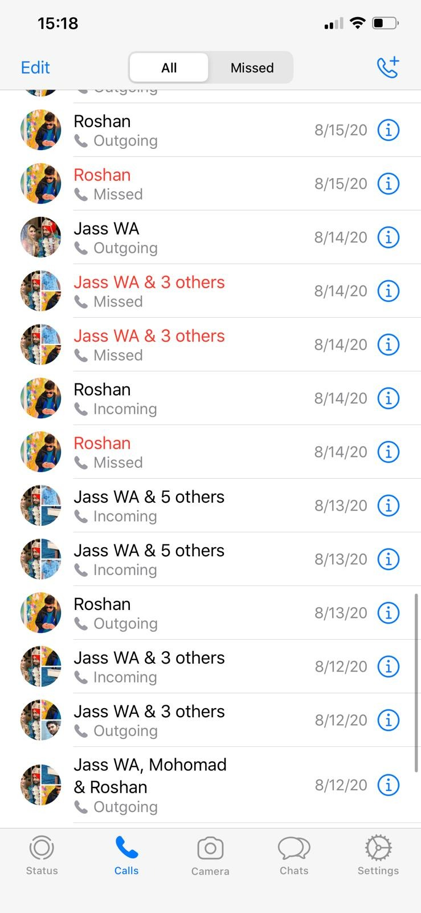

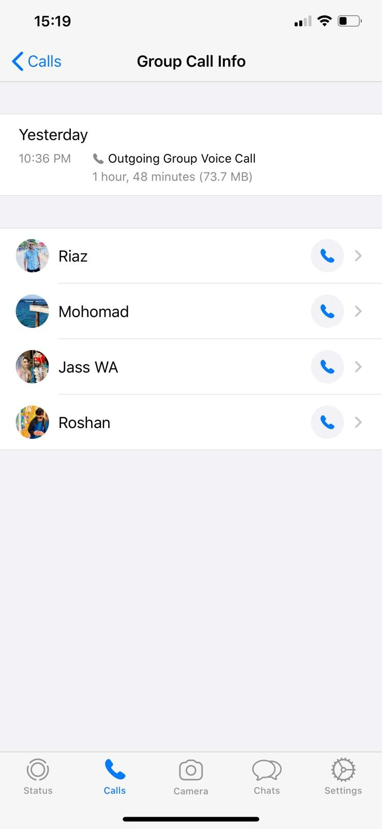

**Date and Time:** 13/09/2020, 10:35 pm – 12:30 am

**Venue:** WhatsApp call

**Attendees:** Roshan, Singh Jashandeep, Riaz, Kamal & Muhammad **Apologies:** None

**Minutes taken by:** Kamal

**Item 1:** What went well?

* The demonstration of tasks went well.
* Each of the team members participated on the zoom meeting with the client and were engaging.
* Project work was divided equally among the team members and essential resources were accumulated to come up with the best solution.
* Team members had the clear understanding of a project and how it could be achieved.
* Improved backlog requirements.

**Item 2:** What could be improved?

* User interface could be improved.
* Monitoring of actual tasks should be done regularly.
* Each of the members in a group could not attend the call or respond to the text message in some cases because of their busy schedule thus, meeting could have been done several times in a week by mentioning exact date and time.
* We should have broadened our knowledge regarding app development and its convenience to the client and our daily tasks should be controlled and monitored.
* Each task should be finished on estimated time.

**Item 3:** What can we do?

* Email drafts frequently to client and supervisor to get feedbacks.
* As stand up meeting, we are doing on regular basis as well as before our meeting with clients and supervisors, we can increase the time for being more focused on questionaries.
* Give personal feedback and points of views on each of the team members by one another.

**Item 4:** What is not in our control?

* Getting feedback from client and supervisor prior to deadlines as we started our first meeting late.
* Connection problem.

# **Backlog grooming meeting**

**(1st meeting with client):**

*As a part of the client meeting, essential information regarding each process of a project development plan was availed to the client as a form of product backlog. Client gave the feedback relative to our tasks suggesting that the application should be simple and convenient to use making it more user friendly so that each of the supplier team can easily access to the application and its functionalities.*

**(2nd meeting with client):**

In this stage, product backlog was scrupulously reviewed and then it was worked based upon what *sort of functionalities make more sense to apply on the project. As the application was to be developed simple and less time consuming, decision was made to quickly scan the product and store information in the data repository as soon as the user work on it. Thus, we removed some of the trivial information and complex activities that we assumed applicable for an app development.*

**(3rd meeting with client):**

*At this phase, we worked on two of the user stories that had been created and we discussed how it can be improved. Regarding the concept that we built as login is to be done by the user of Babatye team members, the client suggested not to have the login/credentials fill up page to save the time in rush hours. But rather, decision was made that suppliers of Babatye needs to signup/login the application while supplying products. Also, in case the mobile camera does not work while scanning or the barcode is misplaced, users should be made able to fill up required details of a product manually.*

# **Statement of contribution**

## **Project Vision:**

1. Project Overview - Mohammad
2. User Description - Riaz
3. Application Overview - Jashandeep
4. Application Features - Roshan
5. Project Deliverables - Kamal
6. Future Development & Possibilities – Kamal

Report finalised and documented by Kamal

## **Product Backlog:**

1. Brief description - Kamal
2. Associated Problem - Kamal
3. Envisioned Solution - Kamal
4. Definition of Key terms - Kamal
5. Users – Kamal
6. Product Backlog Items - Kamal

Report done and prepared by Kamal

## **Project Plan:**

1. Organization - Riaz
2. Managerial Process - Jashandeep
3. Technical Process - Mohammad
4. Non-functional Requirements – Roshan

Report finalised by Riaz, Jashandeep, Mohammad & Roshan and documented by Kamal

## **Sprint 1:**

1. Theme & Wishlist – Riaz and Mohammad
2. Incoming Product Backlog - Kamal
3. Sprint Backlog – All team members
4. Review meeting – Riaz and Mohammad
5. Retrospective meeting – Jashandeep and Roshan
6. Backlog grooming meeting – Jashandeep and Roshan
7. Statement of contribution – Kamal

Report finalised and documented by Kamal

# **Progress**

|  |  |
| --- | --- |
| Task | Progress |
| Project Vision | Completed |
| Product Backlog | Completed |
| Project Plan | Completed |
| Sprint 1 | Completed |
| Development Demonstration 1 | In progress |
| Sprint 2 | In progress |
| Development Demonstration 2 | In progress |
| Prototype | In progress |

# **Evidence of Progress in Sprint Backlog Tasks**

1. T1 Login page – Riaz

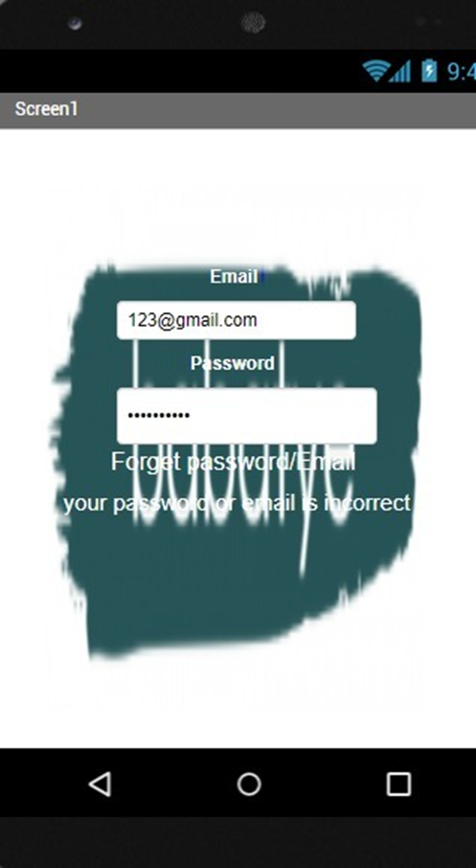

1. T2 Incorrect credentials – Riaz



1. T3 Verification – Riaz

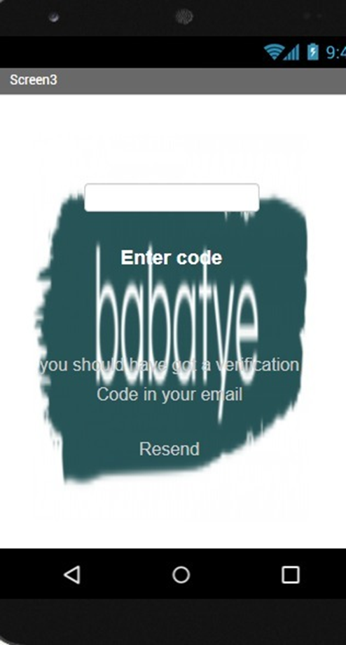

1. T4 Successful account creation – Mohammad

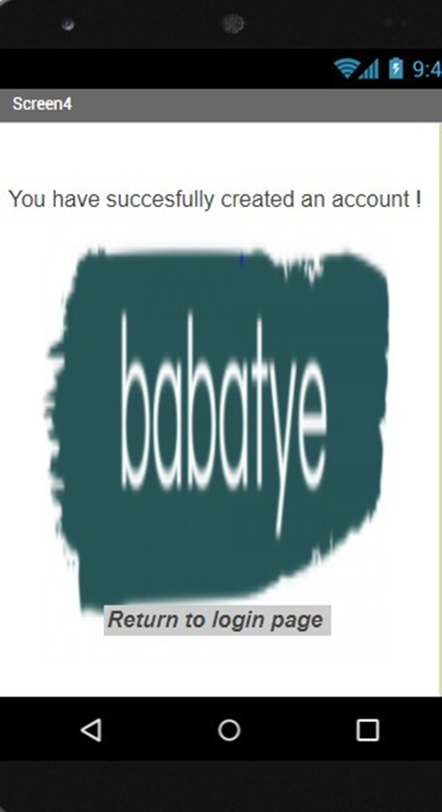

1. T5 Data Repository – Kamal & Jashandeep

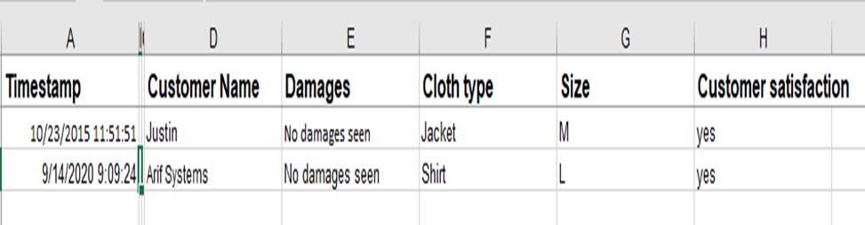

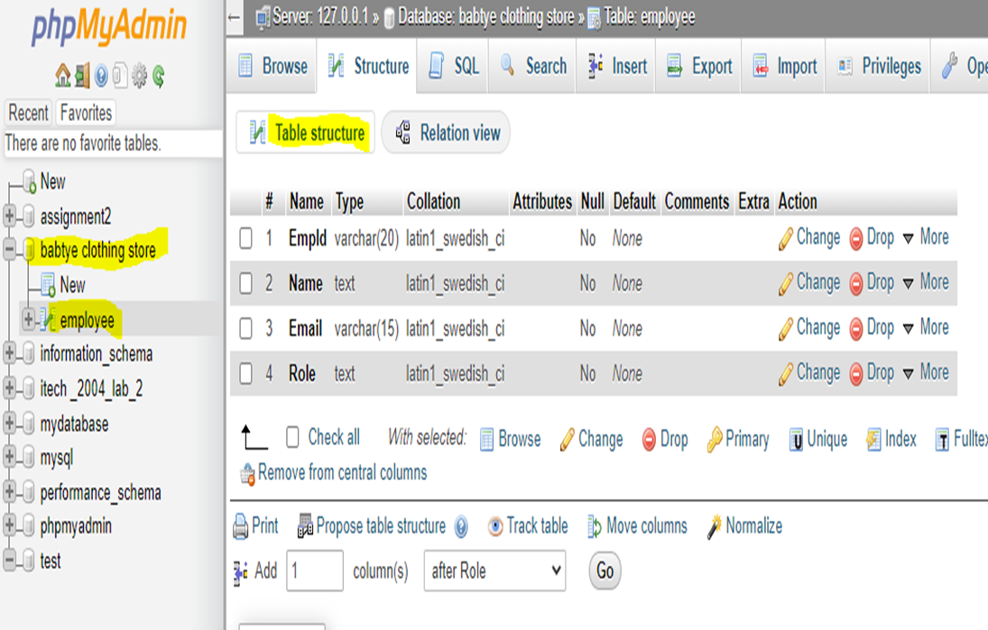

1. T6 Main Interface – Roshan

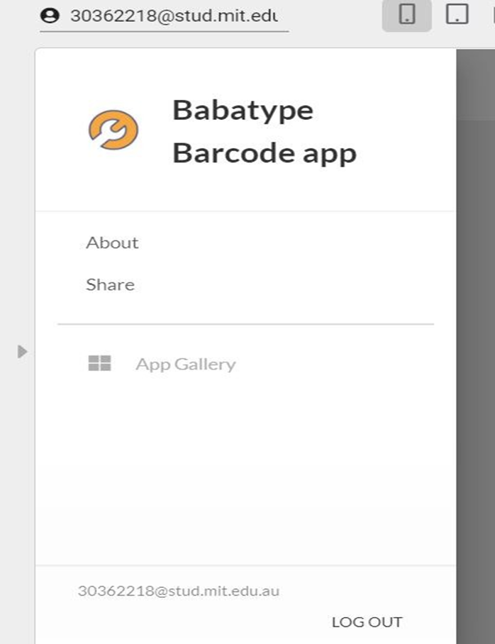

1. T7 Scanning Interface - Roshan & Mohammad

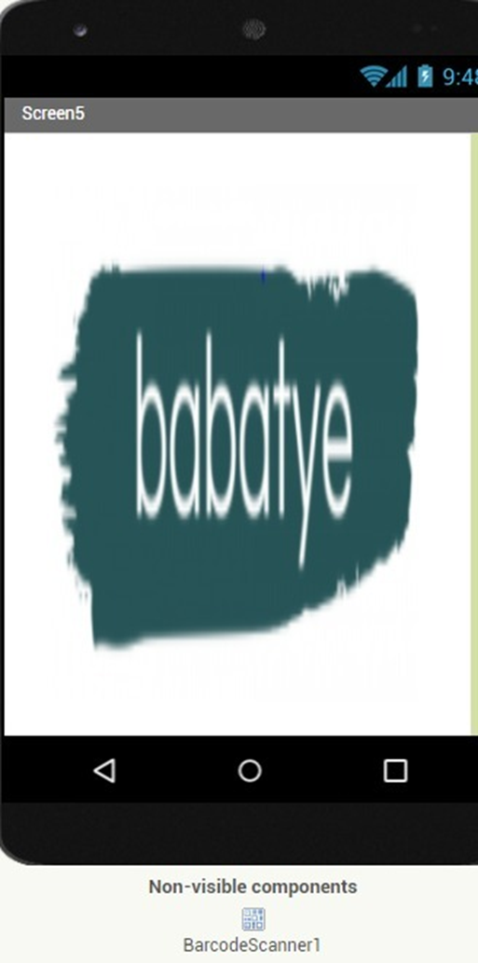

1. T8 Information of scanned cloths – Jashandeep

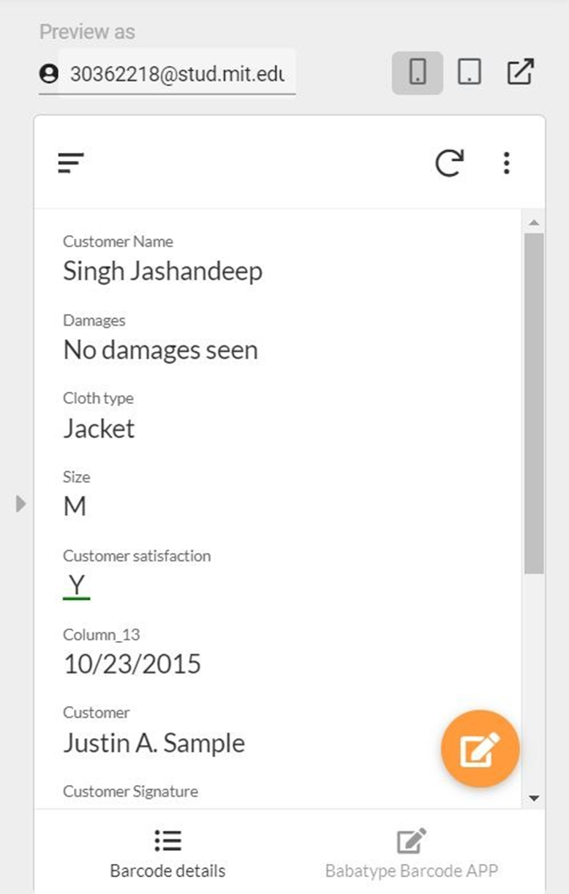

1. T9 Activity diagram – Kamal

